# Logical Framework Approach (LFA)

## Log Frame LFA as a process

LFA is a design methodology which impose a logical discipline on the project design Team and is mainly used in the design, monitoring and evaluation of International Development Projects

The core of the Log frame is the Temporal logic model that runs through the Matrix

This takes the form of a series of connected propositions ie

1. If the Activities are implemented and the Assumptions hold the Output will be realised
2. If the Outputs are delivered and the Assumptions hold then the Purpose will be achieved
3. If the Purpose is achieved and the Assumptions hold then the Goal will be Achieved.

[1]

***The Critical steps in the Project Design Process are outlined below***

**Situational Analysis:**

Analysis of the situation surrounding the problem

Feasibility study, Pre appraisal Report

Describes the problem situation in detail identifies the stakeholders and identifies the effects of the problem on them

**Stakeholder Analysis**

An analysis of the people groups or organisations who may influence or be influenced by the problem or potential solution of the problem

First understand the stakeholders: to reveal and discuss the interest or expectations and groups that are important to success of the project.

**Problem Analysis**

If there is no agreement among the parties on the statement of the problem it is unlikely t5hat there will be agreement on the solution

This stage seeks to get consensus on the detailed aspects of the problem

Procedure involves brain storming

Identify the cause and effect relationship

Arrange in a problem tree

**Objective Analysis**

The problem statements are converted into objective statements—develop Objective Tree

Just as the Problem Tree identify a cause and effect relationship the Objective Tree identifies a means and end relationship

The Means-End relationship show the means by which the project can achieve the desired ends or future desirable conditions.

**Alternative Analysis**

The objective Tree usually shows the large number of strategies or means- ends links that could contribute to the solution to the problem

Participants must select the most promising strategies as it may not be feasible to treat with all the identified strategies due to limited resources.

**Activities planning**

After defining the Objectives and specifying how they will be measured and where and how the information will be found , it is time to get ion the detailed planning phase

Determine what activities are required to achieve each objective

# Logical Framework Matrix

# The Log frame matrix is a project Planning tool

# A log frame is a tool for improving the planning, implementation, management, monitoring and evaluation of projects. The log frame is a way of structuring the main elements in a project and highlighting the logical linkages between them

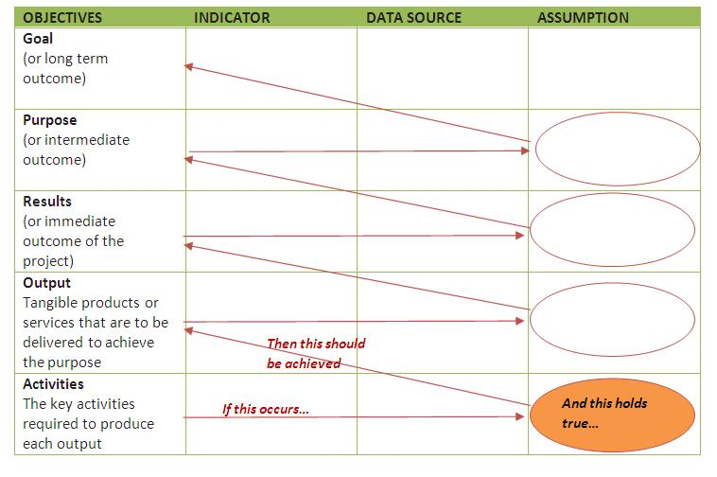

2

# Stakeholder Analysis

**Why is the Analysis Useful ?**

Policy makers and managers can use a Stakeholder Analysis to identify the key actors and to assess their knowledge interest positions allies and competence related to the policy. This allows policy makers and managers to interact more effectively with key stake holders and increase support for a given Project or Program

When conducted before a policy or program is implemented Policy Makers and Managers can detect and act to prevent potential misunderstandings about and or opposition to the Policy or program

When used to guide implementation the Policy or Program is more likely to succeed’\.

**What are the Steps in Stakeholder Analysis**

1. Planning the Process
2. Selecting and defining a Policy
3. Identify key Stakeholders
4. Adapting the Tool
5. Collecting and Recording information
6. Filling in Stakeholder Table
7. Analysing Stakeholder Table
8. Using the Information

**What is Stakeholder Analysis**

Stakeholder Analysis is a process of systematically gathering and analysing qualitative information to determine whose interest should be taken into account when developing or implementing a Policy/Program

**Who is a Stakeholder**

Stakeholders in a process are actors ( persons or organisations) with a vested interest in the policy or program being promoted. These stakeholders or interested parties can usually be grouped into the following categories

International Donors ; National political (legislators Governors ) Public (Ministries MOH MOF etc) Labour Unions Commercial private for Profit Private non Profit ) NGOs Foundations Civil Society and users (consumers )

**Which Stakeholder Characteristics are Analysed**

The analysis includes such characteristics as

Knowledge of the Policy

Interest related to the Policy

Position for or against the Policy

Potential alliances with other stakeholders

Ability to affect the policy process through power influence leadership.

**What can be achieved with Stakeholder Analysis**

1. Stakeholder Analysis yields useful and accurate information about these p[erson or organisations that have an interest in the Project /Program
2. The information can be useful to develop action plans to increase support for the Project
3. Useful to guide participation / consensus building process
4. Useful to develop and implement strategic communication advocacy and negotiating plans.

**Purpose of the stakeholder Analysis**

The purpose of the Stakeholder Analysis is to inform the Project Board/ Project Manager who should contribute to the project ; where barriers might be and the actions that need to be taken before detailed project planning .

1.